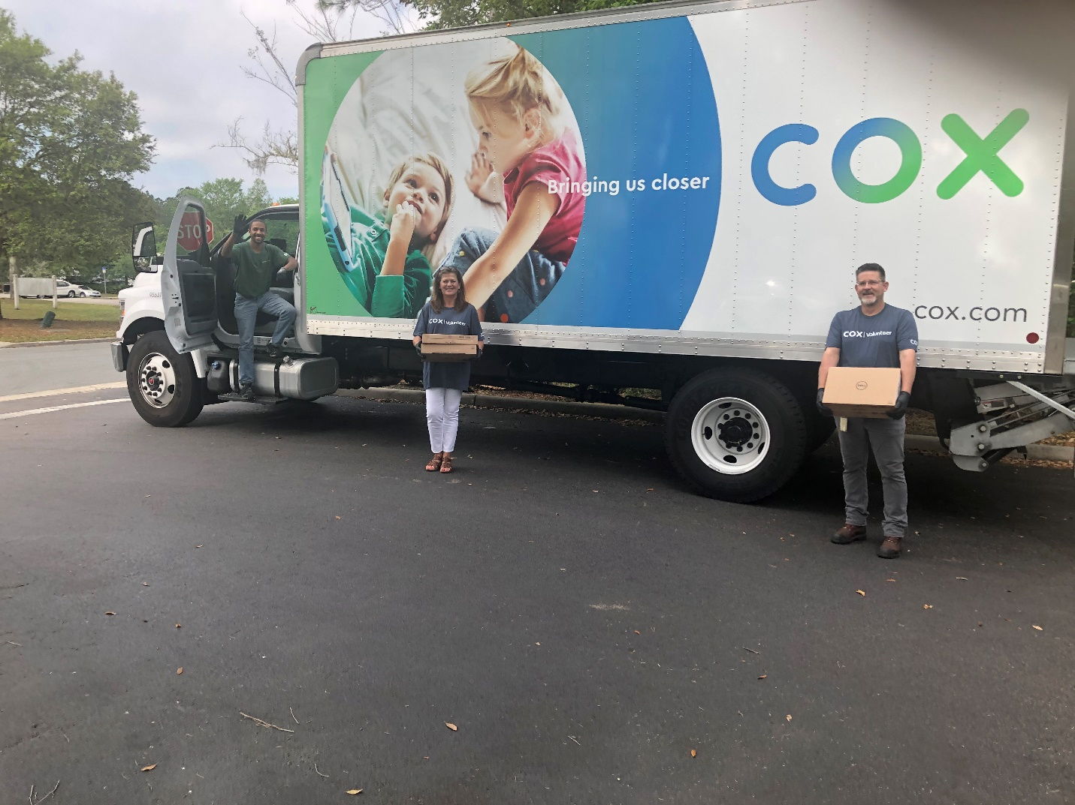
Cox volunteers Evan Paterson, Aimee Pfannenstiel and David Terrell practice social distancing while distributing needed computers at a drive-up outreach Thursday.

